Circle one verb in each underlined pair to complete the sentence using Standard English.

We **was/were** planning to hold a cake sale at school.

I **was/were** chosen to design the posters.

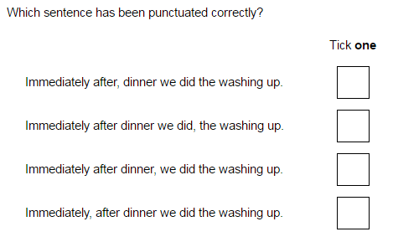

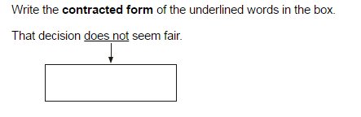

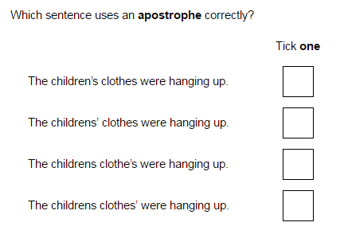

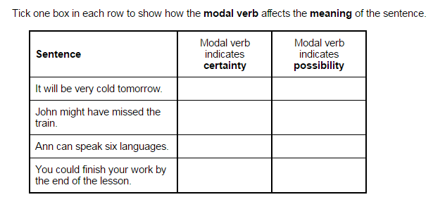

Circle all the **pronouns** in the sentence below.

They bought new jumpers for themselves and a warm scarf for Dad.

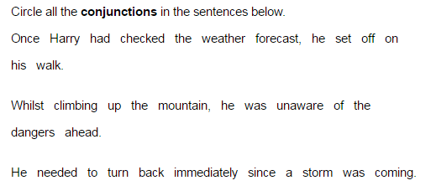

Complete the sentence with an **adjective**  formed from the verb create.

The artist was very __________ and produced many original works.

Write a sentence using the word cover as a noun.

Write a sentence using the word cover as a verb.

make sure your sentences are punctuated correctly.

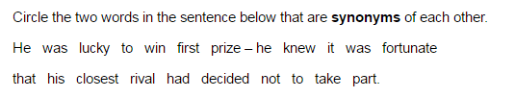

Re write the sentence below using a **subordinate clause**. Remember to punctuate your sentence correctly.

The children played on the swings.

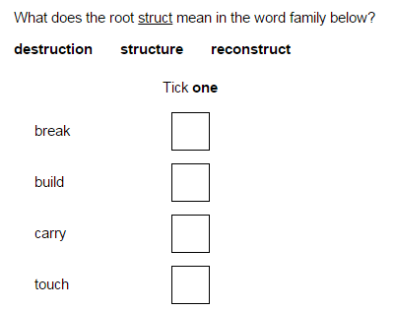

Circle all the words in the sentences below that should start with a **capital letter.**

henry tudor married his first wife, Catherine, in june 1509, they married in London.

Rewrite the sentence below as **direct speech.**

Remember to punctuate your answer correctly.

She asked if he wanted a banana.

She asked him……………………………………..

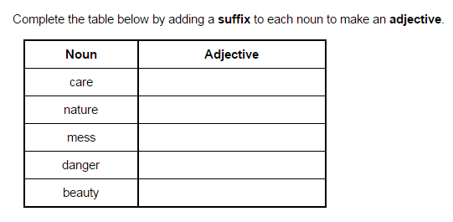

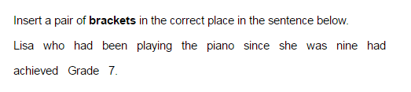

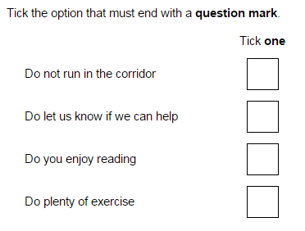

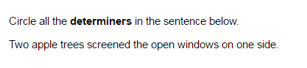

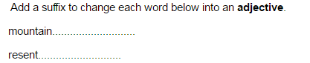

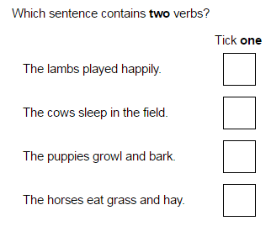

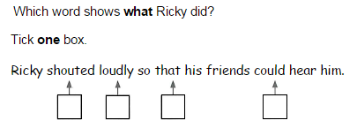

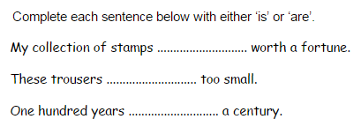

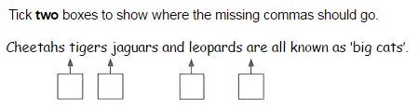

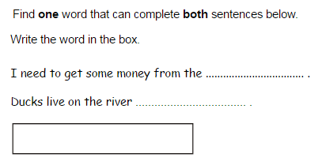

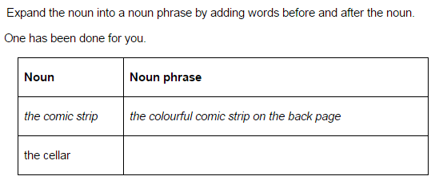

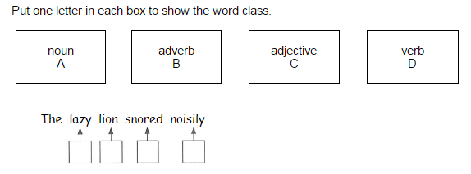

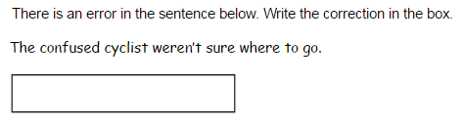

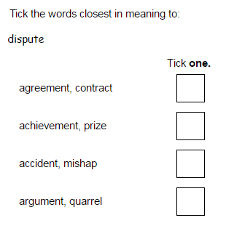

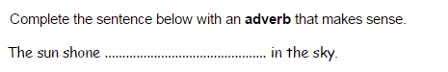

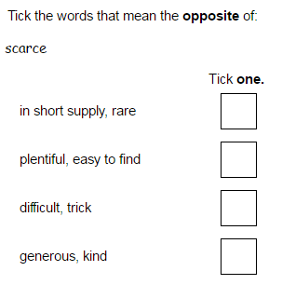

In the sentences below, is the word **bandage** a verb (V) or a noun (N)?

I had to bandage my arm. V/N

I put a bandage on my arm. V/N

In the sentences below, is the word **walk** a verb (V) or a noun (N)?

went for a walk. V/N

He walks 2 miles to work. V/N

In the sentences below, is the word **fast** a verb (V) or a noun (N)?

Modern man leads a fast life. Ad/Av

he drove the car fast. Ad/Av

In the sentences below, is the word **weekly** an adjective (Ad) or an adverb (Av)?

This is our weekly newsletter Av/Ad

The newsletter omes out weekly. Av/Ad

One of the sentences below needs a comma. Say where it should go and explain why.

Before I go to school I kiss my mum goodbye.

I kiss my mum good bye before I go to school.

The sentences below have exactly same meaning. Explain why one has a comma and not the other.

At 3:15pm, school finishes.

School finishes as 3:15pm

Underline all the determiners in this sentence.

There were fifty apples on the apple tree until some fell off.

Underline all the relative clauses in this passage.

Dick Turpin, whose real name is Richard Turpin, was born in Essex in 1705. His dad, Richard Turpin, was a butcher which means he sold meat.

Add an appropriate fronted adverbial to this sentence.

………………………. he climbed a tree and watched for his friends.

Add an appropriate relative clause to this sentence.

The car,………………………………………, was driven by Louis Hamilton.